|  |
| --- |
| (DEPARTMENT OF COMPUTER SCIENCE)  Institute Of Engineering & Science IPS Academy(M.P.)  This is to certify that the project entitled " Furniture E-Commerce Website " the student of 5th SEM  in BTECH (AIML, CSIT) Institute Of Engineering & Science IPS Academy. Done by Drishti Sharma, Aastha Jain, Anuradha Gurjar, Aaliyah Siddiqui , **Piyush Patel**, Pradumn Raghuwanshi **and Pragyey Patel u**nder the guidance and supervision **of Mr. Anand Gupta** from **Ypsilon IT Solutions, Indore** on the partial fulfilment for the requirement of the degree in BTECH(AIML, CSIT) in **Institute Of Engineering & Science IPS Academy** has been completed a record Bonafede work this work is anticipated in well-disciplined attitude.  This project report is up to the standard both in respect of its contents & it’s literally presentation for begin referred to the examinees.  I wish them all the success.    **External Examiner**  **Prof Dr. Ved K Gupta**  **Prof. & Head**  **Department Of Computer Science**  **IES IPS INDORE(M.P)**  **Date: 24 june 2025** |
| **JUNE 2025**    **CERTIFICATE**      This is to certify that DRISHTI SHARMA, AASTHA JAIN, ANURADHA GURJAR, AALIYAH SIDDIQUI, PRAGYEY PATEL, PRADUMN RAGHUWANSHI AND PIYUSH PATEL of CSE **- 5th Semester** from **Institute Of Engineering & Science IPS Academy, INDORE** has successfully completed internship program in our organization from **12th MAY 2025** to **24th JUNE 2025**. During Period he worked on our client project **“FURNITURE E-COMMERCE”** using **Java & Project Development Technologies.**    During this period, he has demonstrated exceptional skills & dedication in the assigned task. We are confident that Intern has gained valuable experience & knowledge during this time. We wish him all the best for future endeavors.  **For Ypsilon IT Solutions Pvt. Ltd.,**      **Authorized Signatory**  **Head Operations & HR**      **YPSILON IT SOLUTIONS PVT. LTD.**  B-Wing, Abhay Prashal, Race Course Road, Indore - 452003 Mob.: +91 93021 22878 | Website:  [www.ypsilonitsolutions.com | Em](http://www.ypsilonitsolutions.com/)ail:info@ypsilonitsolutions.com |
| SELF ATTESTATION      I hereby declare that this project report titled “Furniture E-Commerce ” submitted by DRISHTI SHARMA,   AASTHA JAIN, ANURADHA GURJAR, AALIYAH, PRAGYEY PATEL, PRADUMN RAGHUWANSHI   AND PIYUSH PATEL to Institute of Engineering & Science IPS Academy, Indore in fulfilment for the award   of Bachelor Of Technology in Department Of Computer Science And Engineering (CSE) is a result of authentic   work under taken by me under the guidance of Mr. Anand Gupta at Ypsilon IT Solutions, Indore. The same has   not been submitted by us to this or any other university for any other graduate/post graduate course whatsoever. |
| ACKNOWLEDGEMENT    We convey our gratitude to all those who have helped us to reach a stage where We have immense confidence to launch our career in the competitive field of Information Technology. As an out coming software developer, it is our duty to increase efficiency and to give highest level to nation. Such type of project work inspires us to create my creativity and come out with flying colours.  It is our great pleasure that we present this report on project entitled “FURNITURE E-COMMERCE WEBSITE”. We are extremely grateful to project guide **Mr. Anand Gupta at Ypsilon IT Solutions, Indore** for giving me an opportunity to undertake this project in this esteemed organization and supporting me to complete this project.  We gratefully acknowledge our profound indebtedness towards **Dr. VED K GUPTA (HOD,Department of Computer Science and Engineering , IES IPS ,INDORE)** **Reader. Prof. Sunil Joshi, Prof. Satish Pawar,**  **Prof. Sumeet Dhillon,**  **Prof. Pranita Jain Prof. Mukesh Azad, Prof. Usha Tigga, Prof. Garima Jain,**  **Prof. Nupur Modh** and all other staff members of CSE department for their valuable guidance, excellent supervision and constant encouragement during the entire course of work.  We also that all the visible and invisible hands, which help us to complete the project with the feeling of success. |
| **PROJECT INDEX**     |  |  |  | | --- | --- | --- | | **S.**  **No.** | **CONTENT** | **Page No.** | | 1. | **INTRODUCTION** | 7. | |  | 1.1 Introduction Of the Initiative  1.2 Need Of the Project  1.3 Objective Of Project  1.4 Pros and Cons of The Project  1.5 Scope Of the Project |  | | 2. | **INFORMATION GATHERING** | 9. | |  | 2.1 Information Gathering Techniques  2.2 On-site Visit Observation  2.3 Indirect Personal Observation |  | | 3. | **TOOLS AND ENVIROMENT** | 11. | |  | 3.1 Software Requirement’s  3.2 O/S Platform  3.3 DBMS Tools  3.4 Front End Tools  3.4 Web Server |  | | 4. | **SPECIFICATIONS** | 12. | |  | 4.1 Modules  4.1.1 Admin Pannel ( Customer Section Management )  4.1.2 Customer Pannel (Product Catalog , Shoping Cart )  4.1.3 Payment Processing , Order Processing 4.2 Limitations |  | | 5. | **DESIGN** | 15. | |  | 5.1 Layout Overview  5.1.1 Header  5.1.2 Hero Banner  5.1.3 Featured Section  5.1.4 Footer 5.2 Design Considerations 5.3 Dynamic Components  5.3.1 JSP Rendering  5.3.2 Servlet Control  5.3.3 Database Integration |  | | 6. | **IMPLEMENTATION** | 26. | |  | 7.1 Snapshots |  | | 7. | **TESTING** | 29. | | 8. | **CONCLUSION** | 31.. | |
| **INTRODUCTION**  **1.1 Introduction Of Project**  In today’s digital age, e-commerce has revolutionized the way we shop, bringing convenience and variety right to our fingertips. The **Furniture E-Commerce Website** project is a step toward transforming the traditional furniture shopping experience into a seamless and user-friendly online platform.  This website aims to provide a virtual showroom where customers can browse, compare, and purchase furniture items from the comfort of their homes. Designed with modern aesthetics and functionality, the platform ensures easy navigation, detailed product descriptions, high-quality images, and secure user authentication and checkout processes.  Our primary goal is to bridge the gap between furniture retailers and customers by offering a platform that supports browsing by categories, filters based on preferences, and access to promotional offers. This project also focuses on ensuring scalability and future integration with real-time inventory and order tracking systems.  Overall, the **Furniture E-Commerce Website** project showcases the blend of technical skills and user-centric design to build an efficient and appealing online furniture shopping experience  .  **1.2 Need**:  The **Furniture E-Commerce Website** is essential to meet the evolving expectations of modern consumers in the home and office furnishing market. Traditional furniture shopping methods are time-consuming, limited by physical store hours, and often lack product variety and transparent comparison options. This platform addresses those limitations through the following key needs:   * **Efficiency and Convenience**: Enables users to browse and purchase furniture from anywhere, reducing the need for store visits. * **Product Variety and Comparison**: Offers a broad catalog with detailed descriptions and filtering options, helping users compare products effortlessly. * **User Control and Flexibility**: Allows customers to manage their orders, view history, and make changes with ease. * **Cost-Effectiveness**: Lowers operational costs for sellers and offers competitive pricing and discounts for customers. * **Enhanced Security**: Secures user data and transactions with modern authentication and encrypted payment methods. * **Data Management**: Gathers insights into user behavior, enabling better inventory and service optimization.   This system fulfills the need for a digital, scalable, and user-focused solution, improving the furniture shopping experience for both customers and vendors.  **1.3 Objective:**    **The primary objective of the Furniture E-Commerce Website is to develop an intuitive, responsive, and efficient online platform that transforms the traditional furniture shopping experience into a convenient digital process. The key objectives include:**   * **To create a user-friendly interface that enables customers to easily browse, search, and purchase furniture items online.** * **To provide detailed product information, including high-quality images, descriptions, prices, and specifications for informed buying decisions.** * **To implement secure login, registration, and payment features that protect user data and ensure smooth transactions.** * **To offer efficient cart and order management, allowing users to add items to cart, place orders, and track their purchases.** * **To support admin functionalities such as product management, inventory control, and order processing.** * **To ensure mobile responsiveness and cross-browser compatibility for accessibility on all devices.** * **To enable future scalability for integrating features like customer reviews, personalized recommendations, and real-time inventory tracking.**   **By fulfilling these objectives, the website aims to enhance customer satisfaction, increase sales for vendors, and simplify the overall furniture shopping process.**  **PROS:**   1. **Convenience: Customers can browse and purchase furniture from home at any time.** 2. **Wide Product Range: Offers a broader selection of products than a physical showroom.** 3. **Time-Saving: Reduces the time spent traveling to stores and comparing options manually.** 4. **24/7 Availability: The website is always accessible, even outside of regular business hours.** 5. **Detailed Product Info: Provides images, specifications, prices, and user ratings to support informed decisions.** 6. **Admin Control: Admin panel allows efficient management of products, categories, and orders.**   **CONS:**   1. **No Physical Inspection: Customers can't touch or test the furniture before buying.** 2. **Delivery Delays: Logistics issues may cause delays in shipping and delivery.** 3. **Returns & Damages: Handling returns for damaged or mismatched items can be complicated.** 4. **Technical Issues: Website crashes, bugs, or slow loading can affect user experience.** 5. **Security Risks: Potential threats like hacking or data breaches if not properly secured.** 6. **Digital Divide: Not everyone is comfortable with online shopping, especially in rural areas.** |
| **Information Gathering**  **Information gathering for the Furniture E-Commerce Website involves collecting essential data and requirements to build a functional, visually appealing, and user-friendly platform. This phase focuses on identifying the needs, preferences, and expectations of users when it comes to browsing and purchasing furniture online.**  **It also includes gathering technical specifications such as system performance, security requirements, user interface design preferences, and integration needs with features like shopping carts and payment gateways. Consultations with key stakeholders — including customers, store managers, and logistics partners — offer valuable insights into industry standards, user behavior, and current market trends.**  **The collected data forms the foundation for informed design and development, ensuring the platform meets real-world user expectations and follows best practices in the e-commerce domain.**  **2.1 Information Gathering Techniques**  **Information gathering techniques are methods used to collect data, insights, and feedback from various sources to inform decision-making and effective system development. These techniques help ensure that the final product aligns with both user needs and business goals. Below are the main techniques used in this project:**  **2.2 Surveys and Questionnaires**  **Surveys were distributed to potential users and local furniture buyers to gather quantitative data on their shopping habits, design preferences, and common issues with online furniture purchases. This helped us understand:**   * **Preferred types of furniture** * **Important factors like price, durability, and material** * **Trust levels regarding online purchases and delivery services**   **2.3 Focus Groups**  **Focus group discussions were held with small groups of potential users — such as students, working professionals, and homemakers — to collect qualitative feedback. These discussions revealed:**   * **Key pain points in the current online furniture market** * **Desired features like easy comparison, filtering by size/material, and quick delivery** * **User opinions on layout design, trust in brands, and willingness to pay online**       **2.4 Prototyping and Feedback**  Prototypes and mockups of the Furniture E-Commerce Website were created during the early stages of development. These visual representations of the platform allowed stakeholders and potential users to interact with the design before implementation. Feedback was gathered through walkthroughs and usability testing sessions to:   * Validate design assumptions and layout flow * Refine navigation, content presentation, and user interactions * Ensure the platform aligns with user expectations and requirements   This iterative feedback process helped identify areas for improvement and shaped a more intuitive and user-centric interface.  **2.5 Competitive Analysis**  A detailed competitive analysis was conducted by studying leading furniture e-commerce platforms such as Pepperfry, Urban Ladder, and IKEA. The goal was to benchmark against industry standards and identify both best practices and gaps to capitalize on. This analysis focused on:   * Website performance and load times * Navigation structure and user interface design * Product filtering and search functionalities * Checkout process and payment integration * Customer support and return policies   The insights gained helped us define a unique value proposition and informed decisions to improve usability, differentiate from competitors, and deliver a better customer experience. |
| **TOOLS AND ENVIRONMENT**      **3.1 Software Requirements:**    O/S Platform : Windows 11  User Interface : HTML  Client-Side Scripting : JavaScript  Programming language : JAVA  IDE Tools : Eclipse IDE  Database : MYSQL     **3.2 O/S Platform:**      Windows -11 is excellent graphical user and provide greater security features and better   environment which is user friendly and reliable. It provides password and many other things   admin permission to work in this environment.    **3.3 DBMS Tools:** We select the MYSQL for DBMS tools. Because MYSQL provides best feature and better   technology. It provides high security.    **3.4 Front End Tools:** I am using (HTML, CSS, JAVA, FX etc). Because HTML document is small and   hence easy to send over the net. It is small because it does not include formatted   information.   **3.5 Web Server:**     Here I used a tomcat webserver for providing the server to the website. |
| |  | | --- | | **4. SPECIFICATIONS**  **4.1 Modules**  **📌 4.1.1 Admin Panel (Customer Section Management)**  **The Admin Panel enables authorized administrators to manage users, monitor orders, and maintain overall platform functionality.**  **Key Features:**  **- Customer Management: View, update, or delete registered customer accounts.**  **- Order Monitoring: Track orders placed by customers with status updates (Pending, Shipped, Delivered).**  **- Product Catalog Control: Add, update, or remove products from the catalog, including managing stock levels and uploading images.**  **- Analytics: Optional dashboard showing sales trends, top-selling furniture items, and customer activity.**  **Technology Implementation:**  **- Built using JSP for the UI, backed by Java servlets that access and manipulate customer/order data via JDBC connections to MySQL.**  **🛍️ 4.1.2 Customer Panel (Product Catalog, Shopping Cart)**  **This module is designed for customer interaction, allowing users to browse, select, and purchase furniture items.**  **Key Features:**  **- Product Catalog: Dynamically displays furniture listings with images, names, categories, and prices. Products are fetched from the MySQL database.**  **- Filtering and Search: Customers can filter items by category (e.g., Chairs, Tables, Sofas) or search by keywords.**  **- Shopping Cart: Logged-in users can add products to a virtual cart, update quantities, or remove items.**  **- User Registration & Login: Customers can register or sign in securely to access cart and order history.**  **Technology Implementation:**  **- JSP pages render dynamic content with product loops.**  **- Servlets handle cart actions and forward responses to JSP.**  **- Session management is used for keeping track of user carts.**  **💳 4.1.3 Payment & Order Processing**  **This module handles final transaction steps, converting cart contents into confirmed orders and handling payment simulation.**  **Key Features:**  **- Checkout Workflow: Verifies selected items, shipping info, and total billing amount.**  **- Payment Integration: Simulated payment gateway (e.g., via forms); optionally expandable to real APIs like Razorpay or Stripe.**  **- Order Generation: Once paid, orders are saved in the database along with timestamp, user ID, and delivery status.**  **- Confirmation Page: Displays order summary and invoice, with email/SMS confirmation (optional).**  **Technology Implementation:**  **- Servlet handles payment form submission.**  **- Java code confirms cart data and inserts order data into the MySQL database.**  **- JSP page shows confirmation and summary.** |   **LIMITATIONS**  Despite offering a wide range of features to streamline the online furniture shopping experience, the current implementation of the **Furniture E-Commerce Website** does have certain limitations that can impact functionality, scalability, and user experience. These limitations are important to acknowledge, as they represent areas for future enhancement and optimization.  **🔹 1. Limited Real-Time Inventory Management**  Currently, the system does not support real-time inventory updates when multiple users attempt to purchase the same item simultaneously. This could lead to overselling or displaying outdated availability status.  **🔹 2. Absence of Delivery Tracking**  The project lacks integration with real-time logistics APIs (e.g., Shiprocket, Delhivery, etc.), which prevents users from tracking the delivery status of their orders. Customers can only view a static "order status" without live updates.  **🔹 3. No Recommendation Engine**  The system does not include a personalized recommendation system based on user behavior, search history, or purchase trends. This limits cross-selling and upselling opportunities, which are critical in modern e-commerce platforms.  **🔹 4. No Product Reviews or Ratings**  User-generated reviews and ratings are not implemented, which affects the trustworthiness of products for new customers. Feedback and social proof play a crucial role in customer decision-making.  **🔹 5. Admin Panel is Basic**  The admin dashboard currently offers only basic functionalities such as adding and removing products. It lacks detailed analytics, sales graphs, low stock alerts, bulk uploads, and user management tools that are essential for smooth backend operations.  **🔹 6. No Integration with External Payment Wallets**  Although basic payment processing is implemented, popular Indian wallets like Paytm, PhonePe, and Google Pay are not integrated. This might limit accessibility and convenience for users accustomed to those services.  **🔹 7. Limited Security Measures**  While essential security measures like password hashing and input validation are implemented, the system does not yet include advanced features such as:   * Two-factor authentication (2FA) * Captcha verification to prevent bots * Real-time intrusion detection systems (IDS)   **🔹 8. No Mobile Application**  The current system is web-based only. A dedicated mobile application for Android or iOS is not yet developed, which can limit engagement from mobile-first users and reduce accessibility.  **🔹 9. No Support for Bulk Orders or B2B Features**  The platform is designed primarily for individual retail customers. It does not currently support B2B features like quotation requests, bulk discounts, or scheduled deliveries.  **🔹 10. Limited Accessibility Compliance**  Accessibility for users with disabilities (e.g., screen reader compatibility, high-contrast modes, keyboard-only navigation) has not been fully tested or implemented, making it less inclusive for all user groups. |

**5. DESIGN**5.1 Layout Overview

The homepage (index.jsp) layout is crafted for both aesthetics and usability, supporting dynamic content delivery and responsive interaction.

5.1.1 Header

* **Brand Identity:** Includes logo or site title (e.g., *Home Haven*).
* **Navigation Links:** Present across all pages using JSP includes (), enabling maintainable and consistent UI.

5.1.2 Hero Banner

* Positioned just below the header.
* Uses a CSS background image and overlay text such as *“Discover Comfort & Style.”*
* Can optionally rotate multiple promotional banners using JavaScript or JSP conditionals.

5.1.3 Featured Section

* Fetches featured products from the products table where a column like is_featured = true.
* Each product is displayed in a card format with name, image, and price, and includes an “Add to Cart” button that triggers servlet methods via form POST or AJAX.
* JSP loops through a list of JavaBeans provided by the Servlet to render each item.

5.1.4 Footer

* Includes legal disclaimers, support contact details, and optional social media links.
* Can be enhanced later with newsletter subscription form using JSP and JDBC.

5.2 Design Considerations

* **Mobile Compatibility:** Media queries ensure component resizing for small screens.
* **Performance Optimization:** Images are compressed, JSP caching is used to reduce repetitive DB queries for static homepage content.
* **Security:** Session tracking avoids unauthorized access to user-specific or admin pages. Input validation and character encoding help prevent XSS and SQL injection.
* **Scalability:** The architecture allows new features like personalized recommendations, product reviews, or wishlists to be added with minimal restructuring.  
    
    
    
    
    
  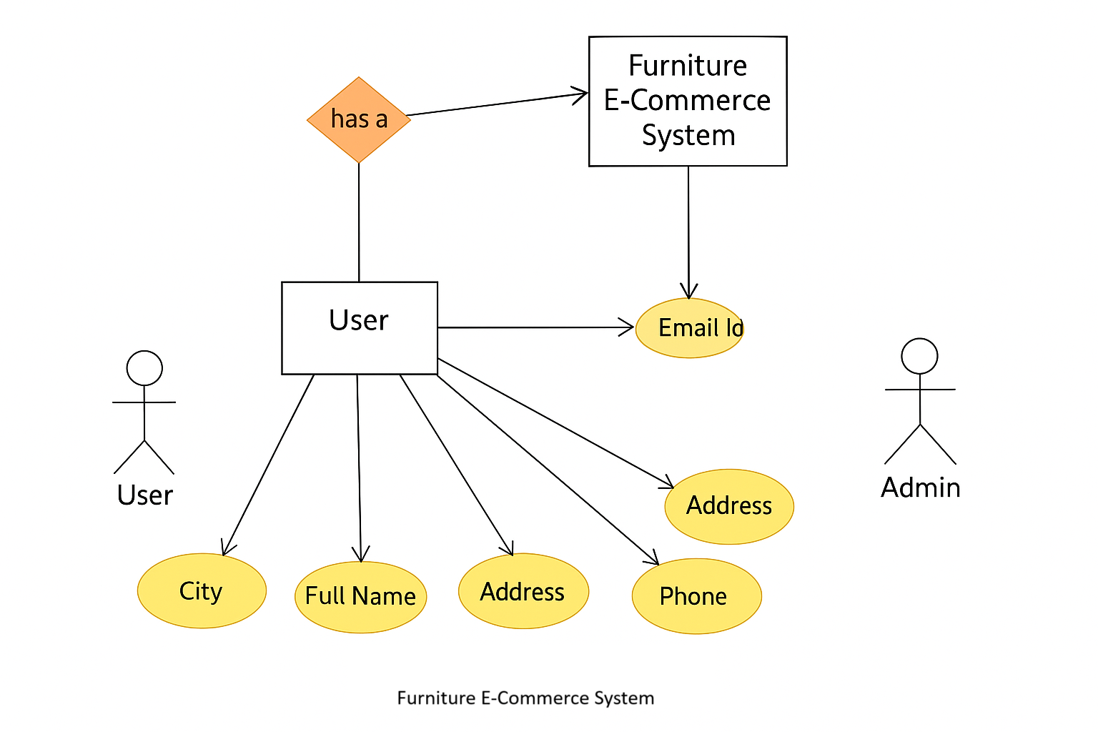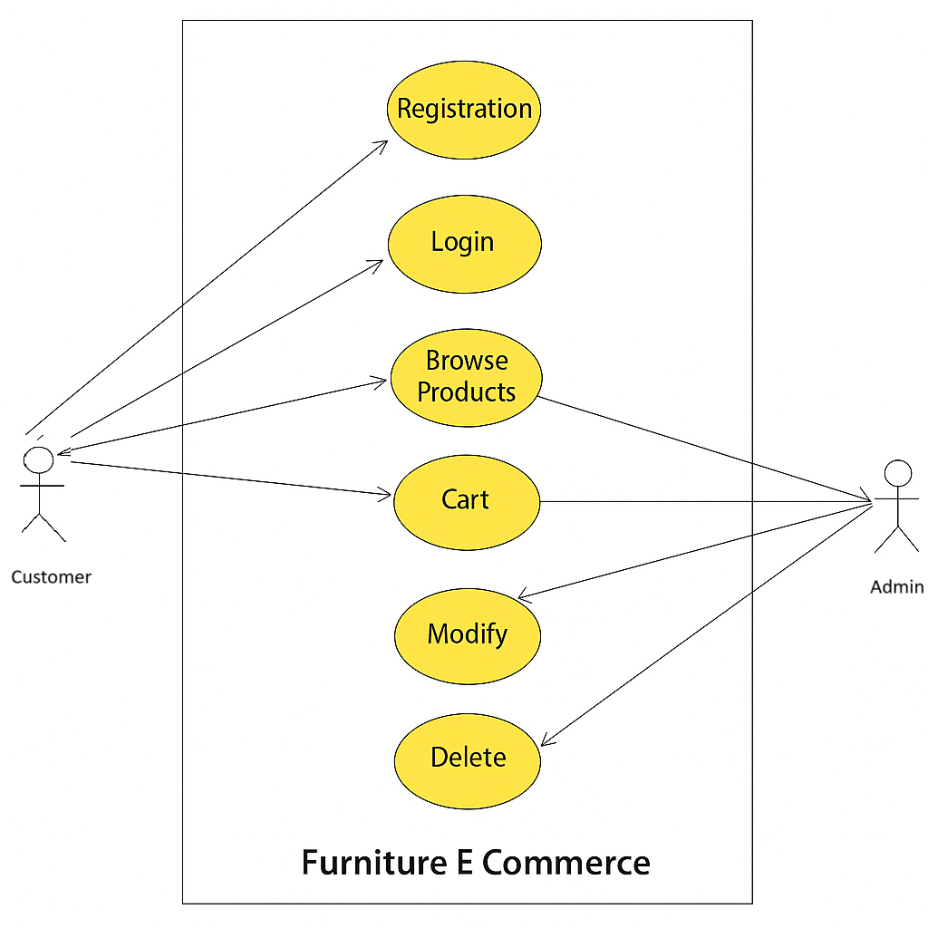

**5.3 Dynamic Components**

**5.3.1 JSP Rendering**

* **JSP pages are integrated with JSTL (, ) and Expression Language (${}).**
* **Components like header and footer are modular and included using .**
* **Optional UI logic like conditional display of login/logout links based on session attributes.**

**5.3.2 Servlet Control**

* **Example: HomeServlet.java retrieves featured products from DAO class ProductDAO.**
* **It initializes a List and uses request.setAttribute() to pass it to index.jsp.**
* **Error handling and logging are implemented using try-catch blocks and Java logging frameworks.**

**5.3.3 Database Integration**

* **Relational database structure includes products, categories, users, and orders tables with foreign keys.**
* **DAO Layer uses JDBC for prepared statements to run SQL queries like SELECT * FROM products WHERE is_featured = 1.**
* **Connection pooling may be added using libraries like Apache DBCP or HikariCP.**

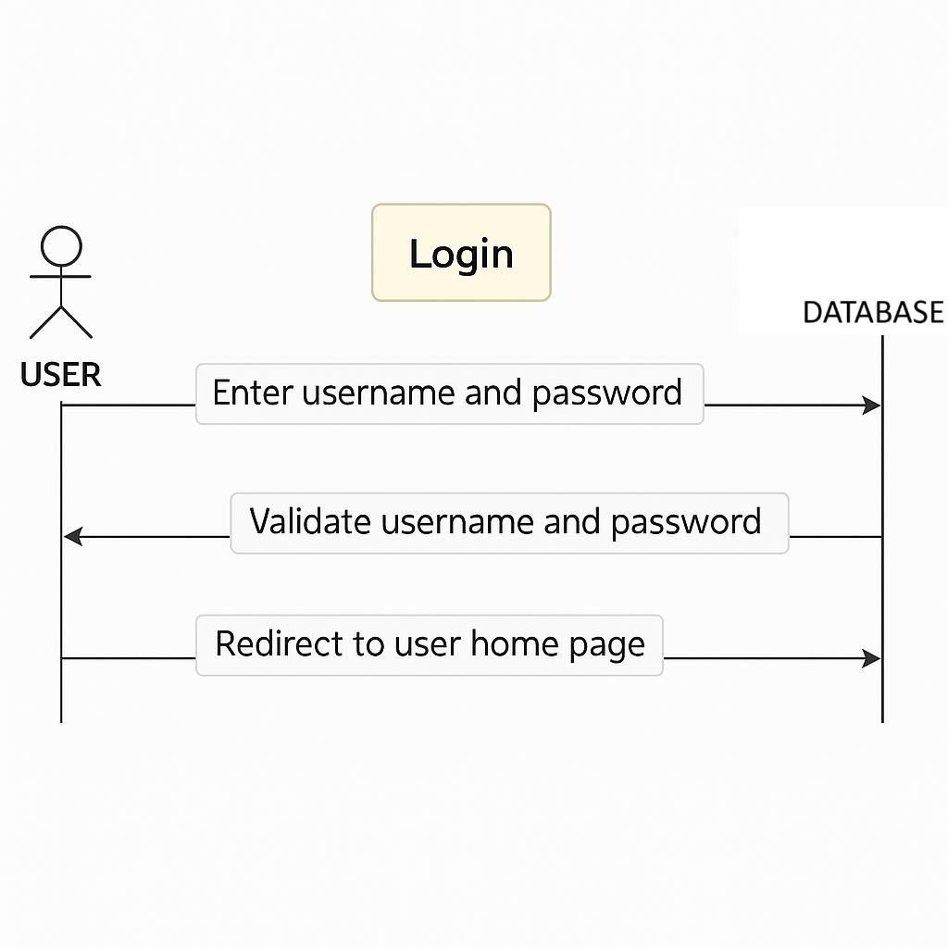

**Registration Sequence Diagram**

The **Registration Sequence Diagram** for the **Furniture E-Commerce Website** outlines the process of how a new user registers on the platform. It demonstrates the interactions between the **User**, **Client Interface**, **Registration Controller**, and the **Database** during the registration workflow.

**Steps:**

1. The user clicks on the **“Register”** option and is directed to the registration page.User fills out the registration form with personal information and submits it.

2. The user enters personal details such as:

Full Drishti Sharma, Astha Jain, Anuradha Gurjar, Aaliyah, Pragyey Patel, Pradumn Raghuwanshi and Piysh Patel,

Email address,

Mobile number,

Password and address

3.On clicking “Submit”, the form data is sent to the backend controller via a POST request.

4.A success response is sent back from the database to the controller confirming the record has been stored.

5.The Registration Controller sends a registration success response back to the Client Interface.

6.The Client Interface displays a registration confirmation to the User.

**## Product Ordering Sequence Diagram**

The **Product Ordering Sequence Diagram** in the **Furniture E-Commerce Website** outlines the step-by-step interactions when a user purchases a furniture item. It highlights how different components — including the user, client interface, product and order controllers, payment gateway, and database — interact during the purchase process.

**Steps:**

1. The user accesses the product catalog and uses search or filter features to browse furniture items. The Client Interface sends the search criteria to the Flight Search Controller.
2. The search/filter parameters are sent to the backend.The Database returns the available flights to the Flight Search Controller.
3. It fetches available products matching the criteria.User selects a flight and proceeds to booking on the Client Interface.
4. Product information is retrieved and sent back.The Booking Controller processes the booking and sends payment details to the Payment Gateway.
5. A list of matching furniture items is displayed for the user.
6. The user adds an item to the cart, views the cart, and clicks **Place Order**.
7. This includes user ID, product ID, quantity, delivery address, and selected payment method.
8. The controller calculates total cost and forwards payment data to the external **Payment Gateway**.
9. It handles the actual financial transaction (card, UPI, etc.) and returns success/failure response.
10. Upon successful payment, the controller creates a new order record in the system.

**## Update Sequence Diagram**

**The Update Sequence Diagram for the Furniture E-Commerce Website illustrates the step-by-step interaction when a registered user updates their personal details—such as Drishti Sharma, Astha Jain, Anuradha Gurjar, Aaliyah, Pragyey Patel, Pradumn Raghuwanshi and Piysh Patel, address, phone number, or email. This diagram represents the communication flow between the system components involved in the update process.**

**Actors and Components:**

* **User: The customer who initiates the update.**
* **Client Interface: The web or mobile front-end application.**
* **Update Controller: The server-side logic that processes user data.**
* **Database: The storage system where user information is securely saved.**

**Steps in the Sequence:**

1. **User Opens Update Form  
   The user navigates to the “My Profile” or “Account Settings” section and opens the update form.**
2. **User Inputs New Details and Submits Form  
   The user modifies fields such as Drishti Sharma, Astha Jain, Anuradha Gurjar, Aaliyah, Pragyey Patel, Pradumn Raghuwanshi and Piyush Patel, email, contact number, or address and clicks the "Update" button.**
3. **Client Interface Sends Request to Update Controller  
   The updated data is packaged and sent from the front-end to the server-side controller via HTTP POST.**
4. **Update Controller Validates Input  
   The controller checks the submitted data for:**
   * **Format correctness (e.g., valid email, numeric phone)**
   * **Required fields being non-empty**
   * **Authentication/session validity**
5. **Valid Data Sent to Database  
   Upon successful validation, the controller creates an SQL query or uses ORM methods to update the user record in the database.**
6. **Database Confirms Update  
   The database executes the update query and returns a success status.**
7. **Update Controller Sends Response to Client Interface  
   A response (e.g., success message or JSON object) is sent back to the front-end.**
8. **Client Interface Displays Confirmation  
   The user sees a confirmation message (e.g., "Profile updated successfully") on the interface.**

**This structured flow ensures:**

* **Secure data handling**
* **Real-time feedback to the user**
* **System-wide consistency of user information**

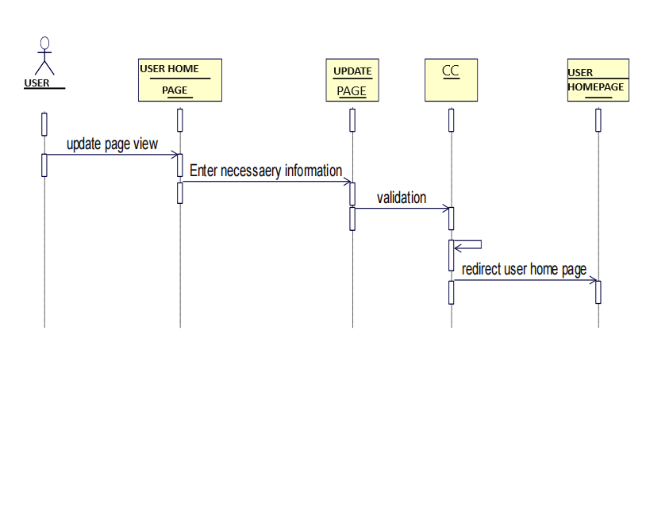

**### Class Diagram**

**The Class Diagram for the Furniture E-Commerce Website outlines the key classes and their relationships, representing the object-oriented structure of the system. It captures the core entities involved in user interaction, product management, order processing, and payment handling.**

**Classes and Attributes**

**1. User**

**Represents the customers registered on the platform.  
Attributes:**

* **username**
* **password**
* **email**
* **address**
* **phone_number**

**2. Product**

**Represents the furniture items listed for sale.  
Attributes:**

* **product_id**
* **product_name**
* **category**
* **description**
* **price**
* **stock_quantity**
* **material**
* **dimensions**
* **image_url**

**3. Order**

**Represents a customer's order containing one or more products.  
Attributes:**

* **order_id**
* **user_id (foreign key referencing User)**
* **order_date**
* **status (e.g., pending, shipped, delivered)**
* **total_amount**

**4. Payment**

**Handles payment details for completed orders.  
Attributes:**

* **payment_id**
* **order_id (foreign key referencing Order)**
* **payment_date**
* **amount**
* **payment_method (e.g., UPI, card, net banking)**
* **payment_status**

**5. Cart**

**Temporarily holds items selected by the user before placing an order.  
Attributes:**

* **cart_id**
* **user_id**
* **created_at**

**6. CartItem**

**Represents each individual product in the user's cart.  
Attributes:**

* **cart_item_id**
* **cart_id (foreign key referencing Cart)**
* **product_id (foreign key referencing Product)**
* **quantity**

**Associations**

* **User → Order  
  A User can place multiple Orders (1-to-many)**
* **Order → Payment  
  Each Order has one Payment (1-to-1)**
* **User → Cart  
  Each User has one Cart (1-to-1)**
* **Cart → CartItem  
  A Cart contains multiple CartItems (1-to-many)**
* **CartItem → Product  
  Each CartItem refers to a single Product (many-to-1)**
* **Order → Product (via OrderDetails if normalized)  
  An Order may contain multiple Products, which can be modeled via a separate OrderItem class if needed**

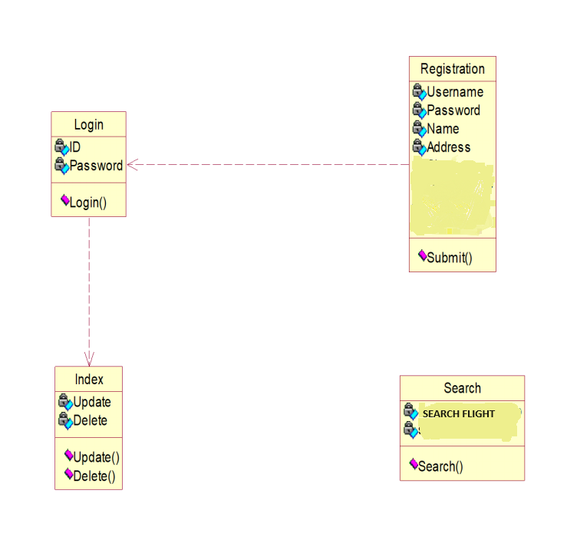

**IMPLEMENTATION**

**Customer Login**

**In the Furniture E-Commerce Website, the implementation is structured around three key modules: User Management, Product Management, and Order Management. The User Management module specifically handles all interactions related to customer registration, login, and authentication.**

**Customer Login Process (User Management Module)**

1. **Login Page Access:  
   The customer navigates to the Login page of the website via the header or navigation menu.**
2. **Credential Input:  
   The customer enters their email address or userDrishti Sharma, Astha Jain, Anuradha Gurjar, Aaliyah, Pragyey Patel, Pradumn Raghuwanshi and Piysh Patel and password into the login form.**
3. **Authentication Request:  
   The web application sends the entered credentials to the Authentication Controller on the server.**
4. **Validation:  
   The controller verifies the entered credentials by checking against stored data in the user database:**
   * **Passwords are hashed using secure algorithms (e.g., bcrypt or SHA-256).**
   * **Validation ensures correct formatting and account status (e.g., active, suspended).**
5. **Authentication Response:**
   * **If the credentials are valid, a session token is created, and the user is authenticated.**
   * **If invalid, an error message is shown asking the user to re-enter credentials.**
6. **Session Management:  
   Upon successful login:**
   * **A session or cookie is created for the user.**
   * **The user gains access to protected pages such as their account dashboard, cart, and order history.**
7. **Access to E-Commerce Services:  
   Once logged in, the customer can:**
   * **Browse and filter furniture products**
   * **Add items to the cart and wishlist**
   * **Place and track orders**
   * **Manage profile and address information**

**Key Modules and Their Focus**

* **User Management:**
  + **Handles registration, login, logout, and profile management**
  + **Ensures authentication, authorization, and secure session handling**
* **Product Management:**
  + **Manages the addition, update, and display of furniture products**
  + **Allows customers to search, filter, and view product details**
* **Order Management:**
  + **Facilitates the cart system, checkout process, order placement, and order tracking**
  + **Maintains order history, status updates, and payment records**

**This implementation ensures a secure, smooth, and user-friendly login process that protects customer data and enhances the overall experience within the Furniture E-Commerce Website.**

### **Customer Registration**

#### Customer registration is a vital part of the Furniture E-Commerce Website as it allows users to create their own secure accounts, enabling personalized services such as order tracking, wishlist creation, address management, and faster checkout experiences.

#### The registration process begins when a new user accesses the Sign-Up page through the website's navigation bar. The user is presented with a registration form that typically includes fields such as:

#### Full Drishti Sharma, Astha Jain, Anuradha Gurjar, Aaliyah, Pragyey Patel, Pradumn Raghuwanshi and Piysh Patel

#### Email Address

#### Mobile Number

#### Password

#### Address (optional during registration, can be added later)

#### Once the user fills in all required fields and submits the form, the data is sent to the backend server where several validations are performed. These include:

#### Ensuring all fields are filled

#### Verifying that the email is not already registered

#### Validating the format of the email and mobile number

#### Ensuring password strength and match between password fields

#### If the data passes validation, the user's details are stored in the database, and a confirmation message is displayed. In many secure implementations, an email verification link is also sent to the user’s email to confirm identity.

#### Upon successful registration, the user is automatically logged in or redirected to the login page. Their account is then ready for activities such as browsing products, adding items to the cart, and placing orders.

#### The registration module plays an important role in user management, as it lays the foundation for secure login, personalized interactions, and a streamlined shopping experience. It also ensures that user data is stored securely and complies with basic data protection practices.

**Steps for Customer Registration**

1. **Access Registration Page  
   The user clicks on the “Sign Up” or “Register” button available in the website's header or login section.**
2. **Fill Out Registration Form  
   The user is presented with a registration form and enters the following details:**
   * **Full Drishti Sharma, Astha Jain, Anuradha Gurjar, Aaliyah, Pragyey Patel, Pradumn Raghuwanshi and Piysh Patel**
   * **Email Address**
   * **Mobile Number**
   * **Password**
   * **Confirm Password**
   * **(Optional) Address or Zip Code**
3. **Form Validation (Client-Side)  
   Basic input validation is performed in the browser:**
   * **All required fields must be filled**
   * **Email format is checked**
   * **Password must meet strength requirements**
   * **Password and Confirm Password must match**
4. **Submit Form  
   After successful validation, the user clicks the “Register” or “Create Account” button.**
5. **Form Validation (Server-Side)  
   On the server, the system performs deeper validation:**
   * **Checks for duplicate email or mobile number**
   * **Sanitizes input to prevent SQL injection or XSS**
   * **Hashes the password using a secure algorithm (e.g., bcrypt)**
6. **Store User Details in Database  
   The validated and processed data is inserted into the user table of the database.**
7. **Welcome Message  
   The system may send:**
   * **A welcome email**
   * **A success message on-screen**
8. **Login or Redirect  
   Upon successful registration, the user is:**
   * **Automatically logged in and redirected to the homepage or dashboard**
   * **Or redirected to the Login Page with a success message**
9. **Account Ready for Use  
   The user can now:**
   * **Browse products**
   * **Add items to cart**
   * **Place orders**
   * **Manage their account and addresses**

**Furniture Search**

**Furniture search** is a key feature of the **Furniture E-Commerce Website**, enabling customers to find furniture items that match their style, budget, and space requirements. It simplifies product discovery through advanced filters and a responsive user interface, improving the overall shopping experience.

Steps for Furniture Search:

1.Access search page:

The customer navigates to the homepage or the "Shop" section of the website.

**2.Use Search or Filters:**

The customer can:

* Enter a **keyword** in the search bar (e.g., "wooden chair", "sofa set").
* Apply filters such as:
  + **Category** (e.g., Chairs, Beds, Tables)
  + **Price Range**
  + **Material Type** (Wood, Metal, Fabric)
  + **Color / Finish**
  + **Size / Dimensions**
  + **Sort By** (Relevance, Price Low to High, Newest First)

3.Form Submission:

When the search or filter is applied, the request is sent to the backend for processing.

4.Display results:

The filtered product list is displayed with thumbnails, prices, brief descriptions, and options to view more details.

5.Product Selection:

The user selects a product to open the product detail page, view specifications, and proceed to add it to the cart.

### **Testing**

Testing is a crucial phase in the development of the **Furniture E-Commerce Website**, ensuring that the platform is functional, reliable, secure, and user-friendly. The goal is to validate that each component and the system as a whole meet user requirements and perform as expected under various conditions.

**Unit Testing**

Unit testing involves verifying the core functionality of individual components such as product display, cart management, and order processing. Test cases are created for:

* **Product listing**: Checking filtering, search, and category functions.
* **Cart and checkout**: Verifying quantity updates, item removal, and total price calculation.
* **Order module**: Validating order placement, confirmation, and data storage.
* **Admin functions**: Testing CRUD (Create, Read, Update, Delete) operations for managing inventory.

Thorough unit testing helps detect bugs early in the development cycle and ensures that each module behaves independently and correctly.

**Testing Techniques**

**• Unit Testing**

Tests individual classes, methods, and functions of the application with both valid and invalid inputs. Ensures reliability at the micro-level.

**• Integration Testing**

Verifies that modules like **user login**, **product database**, **shopping cart**, and **order processing** work together seamlessly.

**• User Interface (UI) Testing**

Checks responsiveness and usability across devices and browsers. Verifies that forms, buttons, links, and navigation elements function as expected.

**• Functional Testing**

Ensures that all core user flows — such as browsing products, adding to cart, and placing orders — function correctly from end to end.

**• Performance Testing**

Measures response time, page load speed, and performance under multiple users or heavy data loads to detect bottlenecks.

**• Security Testing**

Assesses the system for vulnerabilities like:

* SQL Injection
* Cross-site Scripting (XSS)
* Insecure authentication or password handling

**• Accessibility Testing**

Tests compliance with **WCAG** standards, ensuring compatibility with screen readers, keyboard navigation, and alt-text for images.

**• User Acceptance Testing (UAT)**

Engages actual users (admin and customers) to validate whether the system meets their expectations. Feedback from UAT is used to improve usability and design.

**• Regression Testing**

Re-runs earlier test cases after updates or feature additions to ensure that existing features still work correctly without introducing new bugs.

**ADMIN SECTION**

**Login:**

**Dashoard:**

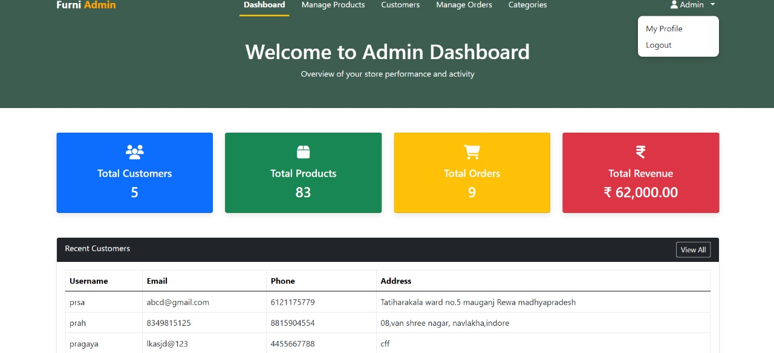

**Categories:**

**Manage Products:**

**Manage Orders:**

**Admin Profile:**

**Logout:**

**Customer Section**

**Customer Profile:**

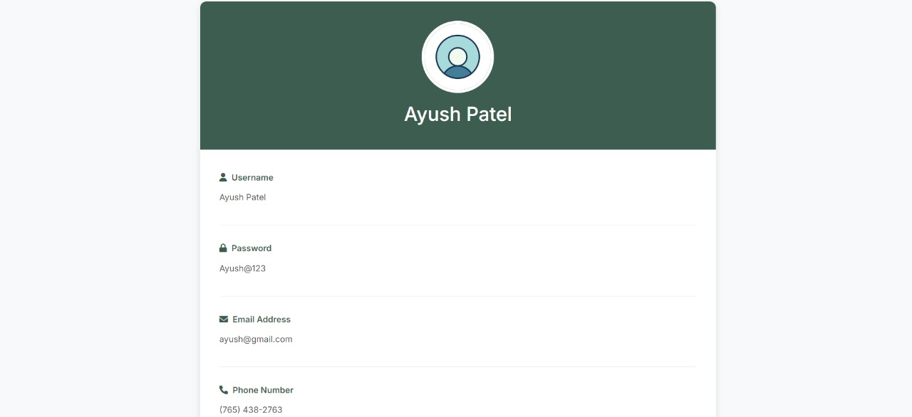

**Cart:**

**Shop Page:**

**Home Page:**

**AddToCart:**

**Edit Profile:**

**CONCLUSION & FUTURE SCOPE**

**CONCLUSION**

The Furniture E-Commerce Website project represents a comprehensive solution that successfully transforms the traditional furniture shopping experience into a modern, digital-first approach. Through systematic implementation using the prototype methodology, we have delivered a robust platform that addresses key challenges in online furniture retail.

**Future Scope:**

**The Furniture E-Commerce Website is designed with extensibility in mind, providing numerous opportunities for enhancement and expansion. The following roadmap outlines potential developments that can further strengthen the platform's market position and user value proposition.**

**Short-term Enhancements (6-12 months):**

**1. Mobile Application Development**

* **Native iOS and Android applications for enhanced mobile shopping experience**
* **Push notifications for order updates, promotions, and personalized recommendations**
* **Mobile-specific features like barcode scanning and voice search**
* **Offline browsing capabilities for previously viewed products**

**2. Advanced Search and Recommendation Engine**

* **AI-powered product recommendations based on browsing history and preferences**
* **Visual search functionality allowing customers to upload images to find similar products**
* **Smart filters considering room size, style preferences, and budget constraints**
* **Personalized homepage with curated product collections**

**3. Enhanced Customer Support**

* **Live chat integration with AI chatbots for instant customer assistance**
* **Video consultation services for interior design advice**
* **Comprehensive FAQ system with searchable knowledge base**
* **Multi-channel support including social media integration**

**Medium-term Developments (1-2 years):**

**4. Augmented Reality (AR) Integration**

* **Virtual furniture placement allowing customers to visualize products in their homes**
* **3D product models with 360-degree viewing capabilities**
* **Room design tools for complete interior planning**
* **AR-based size and fit verification reducing return rates**

**5. Advanced Analytics and Business Intelligence**

* **Comprehensive dashboard for sales analytics and performance metrics**
* **Customer behavior analysis for targeted marketing campaigns**
* **Predictive analytics for inventory management and demand forecasting**
* **A/B testing framework for continuous user experience optimization**

**6. Multi-vendor Marketplace Platform**

* **Support for multiple furniture brands and manufacturers**
* **Vendor management system with performance tracking**
* **Commission-based revenue model for marketplace operations**
* **Quality control and rating systems for vendor accountability**

**7. Sustainability and Social Responsibility Features**

* **Carbon footprint tracking for products and delivery options**
* **Eco-friendly product certifications and filtering**
* **Furniture recycling and trade-in programs**
* **Sustainable packaging options and environmental impact reporting**

**Long-term Vision (2-5 years):**

**8. Internet of Things (IoT) Integration**

* **Smart furniture connectivity for usage analytics and maintenance alerts**
* **Integration with home automation systems**
* **Predictive maintenance scheduling for furniture care**
* **Data-driven insights for future product development**

**9. Blockchain Technology Implementation**

* **Supply chain transparency and authenticity verification**
* **Secure and transparent transaction processing**
* **Digital warranties and product history tracking**
* **Decentralized customer review systems**

**10. Advanced Virtual Reality (VR) Experiences**

* **Virtual showroom experiences for immersive product exploration**
* **VR-based interior design consultations**
* **Virtual reality shopping experiences for remote customers**
* **Collaborative VR spaces for family furniture shopping decisions**

**11. Artificial Intelligence and Machine Learning**

* **Predictive customer service identifying issues before they occur**
* **Dynamic pricing optimization based on market conditions and demand**
* **Automated inventory management with supplier integration**
* **Advanced fraud detection and prevention systems**

**12. Global Expansion Capabilities**

* **Multi-language and multi-currency support**
* **International shipping and logistics integration**
* **Localized product catalogs based on regional preferences**
* **Compliance with international e-commerce regulations**

**Emerging Technology Integration:**

**13. Voice Commerce Integration**

* **Voice-activated shopping through smart speakers**
* **Voice search and navigation capabilities**
* **Audio product descriptions for accessibility**
* **Voice-based customer support interactions**

**14. Social Commerce and Community Features**

* **Social media integration for product sharing and reviews**
* **User-generated content showcasing products in real homes**
* **Interior design community forums and expert advice**
* **Influencer partnerships and collaborative collections**

**15. Advanced Logistics and Delivery**

* **Drone delivery for small furniture items and accessories**
* **Same-day delivery services in major metropolitan areas**
* **Installation and assembly service marketplace**
* **Real-time delivery tracking with customer communication**

**Expected Benefits of Future Enhancements:**

* **Increased Customer Engagement: Advanced features will create more interactive and personalized shopping experiences**
* **Market Differentiation: Cutting-edge technology implementation will set the platform apart from competitors**
* **Revenue Growth: Enhanced functionality and expanded services will create new revenue streams**
* **Operational Efficiency: Automation and AI integration will reduce operational costs and improve accuracy**
* **Customer Loyalty: Superior user experience and innovative features will increase customer retention**
* **Data-Driven Decision Making: Advanced analytics will enable better business decisions and strategic planning**

**The future scope demonstrates the platform's potential for continuous evolution, ensuring long-term relevance and competitiveness in the rapidly changing e-commerce landscape. Each enhancement is designed to add tangible value for both customers and the business while maintaining the core principles of security, reliability, and user-centricity.**

**TEAM CONTRIBUTION**

**Admin panel(entirely) - piyush and pragey**

**Customer panel(entirely) - drishti,aaliyah, anuradha**

**- drishti: my profile,edit profile,delete profile**

**- aaliyah: cart, order**

**- anuradha: login & registration, shop home page**

**Report - pradumn & aastha**

**References and Bibliography:**

**Web Resources**

1. **Oracle. *Java Documentation.*** [**https://docs.oracle.com/javase/**](https://docs.oracle.com/javase/)
2. **W3Schools. *HTML, CSS, JavaScript Tutorials.*** [**https://www.w3schools.com/**](https://www.w3schools.com/)
3. **MySQL Documentation. *MySQL Reference Manual.*** [**https://dev.mysql.com/doc/**](https://dev.mysql.com/doc/)
4. **Apache Tomcat. *Servlet and JSP Container.*** [**https://tomcat.apache.org/**](https://tomcat.apache.org/)
5. **GeeksforGeeks. *E-Commerce System Tutorials.*** [**https://www.geeksforgeeks.org/**](https://www.geeksforgeeks.org/)
6. **Bootstrap. *Front-End Framework.*** [**https://getbootstrap.com/**](https://getbootstrap.com/)

**Books**

1. **Sommerville, Ian. *Software Engineering*, 10th Edition. Pearson Education.**
2. **Pressman, Roger S. *Software Engineering: A Practitioner's Approach*, 8th Edition. McGraw-Hill Education.**
3. **Herbert Schildt. *Java: The Complete Reference*, 11th Edition. McGraw-Hill Education.**

**Project-Based References**

* **Design inspiration from platforms like Pepperfry, Urban Ladder, and IKEA for UI/UX structure.**
* **Code snippets and project structure guidance from Java and JSP-based e-commerce tutorials on YouTube and GitHub repositories.**